INTERNSHIP REPORT

Domain: Web Development

What is Web?

All the public websites or pages that users can access on their local computers and other devices through the internet.

What is Network?

A network is a group of two or more computers or other electronic devices that are inter connected for the purpose of exchanging data and sharing resources .

Computer Networks

* Communicating using email , video , instant messaging etc.
* Sharing devices such as printers , scanners etc.
* Sharing files.
* Sharing software and operating programs on remote systems.
* Allowing network users to easily access and maintain information.

Web design is the planning and creation of websites this includes a number of separate skills that’s all fall under the umbrella of web design.

Some examples of these skills are

* Information architecture ,user interface ,site structure ,navigation , layout ,colors and overall integrity .All of these skills are combined with the principles of design to create a website that meets the goals of the company or individual from whom that site is being created.

What is HTML?

* It stands for Hyper Text Markup Language .
* HTML is the standard markup language for creating webpages.
* HTML consists of a series of elements
* HTML elements tell the browser how to display the content.
* HTML elements label pieces of content such as “this is a heading”, “this is a paragraph”, “this is a link” etc.

Basic HTML programs

<html>

<head><title>HTML basic Codes</title></head>

<body>

Welcome to keonics

</body<body>

<h1>Heading 1</h1>

<h2>Heading 2</h2>

<h3>Heading 3</h3>

<h4>Heading 4</h4>

<h5>Heading 5</h5>

<h6>Heading 6</h6>

</body>

<body>

Let us learn text formatting <br>

<b>This is in bold </b><br>

<h6><b><u>keonic computer center</u></b></h6><br>

<i>This text is in italic</i><br>

<u>This text is in underline </u><br>

<big>This text is big in size</big><br>

<small>This text is small in size</small><br>

<strike>This text is in strike through</strike><br>

H<sub>2</sub>O here is 2 lower down by using subscript tag <br>

(a+b)<sup>2</sup>here is 2 rised up by using superscript tag <br>

<b><i><u>This text has all three features </u></i></b>

</body>

<body>

<img src = "C:\Users\Lenovo\Desktop\web design\rosepic.jpg" width="104" height="142">&nbsp;&nbsp;&nbsp;&nbsp;

<img src="rosepic.jpg" width="104" height="142">

</body>

<body>

<p>the<abbr title="World Health Organization">WHO</abbr>was found in 1948 </p>

<p> Can i get this <abbr title ="As soon as possible ">ASAP</abbr>?</p>

</body>

<body>

<bdo dir ="rtl">

Here is some text written from right to left </bdo>

<p>this is a normal paragraph

<blockquote>

This text is having left indentation</blockquote>

<p>This is a normal paragraph</p>

</body>

<body style="background-color:lightblue">

<hr>

<h1><u>Back groung color using style tag</u></h1>

<p style="font-family:vivaldi;color:red;font-size:35px">

This text is in vivaldi and red</p>

<p style="font-size:55px">This text is 55 pixcle high</p>

<hr>

</body>

<body style="background-color:darkblue"><h2 style ="background-color:red">This is headline 2 style background is red in color </h2>

<p style="background-color:green">This paragragh background color is green in color : Mysore is beautiful city in Karnataka,which is famous for its heritage placws and ancient buuldings.

</p>

</body>

<body>

<p>An image<img src="rosepic.jpg" align="top" width="50" height="35">With align="top"</p>

<p>An image<img src="rosepic.jpg" align="middle" width="50" height="35">With align="middle"</p>

<p>An image<img src="rosepic.jpg" align="bottom" width="50" height="35">With align="bottom"</p>

<p><img src="rosepic.jpg" width="50" height="35">An image before the text </p>

<p> an image after the text<img src="rosepic.jpg" width="50" height="35"></p>

</body>

<body>

<a href="pgm1.html">My first web page </a> This is a hyperlink to my existing web page<br>

<a href="http://www.google.com">google</a> The finest search engine<br>

<a href="http://www.yahoo.com">yahoo</a> This is a weblink to website on the world wide web

</body>

<body>

<hr>

<h1 style="text-align:center">Table of contents </h1>

<hr>

<a href="#ch1">Chapter 1</a><br>

<a href="#ch2">Chapter 2</a><br>

<a href="#ch3">Chapter 3</a><br>

<a href="#ch4">Chapter 4</a><br>

<a href="#ch5">Chapter 5</a>

<hr>

<a name="ch1"><h1>Chapter 1</h1>

<p>

<a name="ch2"><h1>Chapter 2</h1>

<p>

<a name="ch3"><h1>Chapter 3</h1>

<p>

<a name="ch4"><h1>Chapter 4</h1>

<p>

<a name="ch5"><h1>Chapter 5</h1>

<p>

</p></body>

<body>

<h4>With frame="border":</h4>

<table frame="border">

<tr>

<td>First </td>

<td>Row</td>

</tr>

<tr>

<td>Second</td>

<td>Row</td>

</tr>

</table>

<h4>With frame="void":</h4>

<table frame="void">

<tr>

<td>First </td>

<td>Row</td>

</tr>

<tr>

<td>Second</td>

<td>Row</td>

</tr>

</table>

<h4>With frame="below":</h4>

<table frame="below">

<tr>

<td>First </td>

<td>Row</td>

</tr>

<tr>

<td>Second</td>

<td>Row</td>

</tr>

</table>

<h4>With frame="above":</h4>

<table frame="above">

<tr>

<td>First </td>

<td>Row</td>

</tr>

<tr>

<td>Second</td>

<td>Row</td>

</tr>

</table>

<h4>With frame="vsides":</h4>

<table frame="vsides">

<tr>

<td>First </td>

<td>Row</td>

</tr>

<tr>

<td>Second</td>

<td>Row</td>

</tr>

</table>

<h4>With frame="hsides":</h4>

<table frame="hsides">

<tr>

<td>First </td>

<td>Row</td>

</tr>

<tr>

<td>Second</td>

<td>Row</td>

</tr>

</table>

<h4>With frame="lhs":</h4>

<table frame="lhs">

<tr>

<td>First </td>

<td>Row</td>

</tr>

<tr>

<td>Second</td>

<td>Row</td>

</tr>

</table>

<h4>With frame="rhs":</h4>

<table frame="rhs">

<tr>

<td>First </td>

<td>Row</td>

</tr>

<tr>

<td>Second</td>

<td>Row</td>

</tr>

</table>

</body>

<body>

<h1>A table 3 rows and 2 columns </h1>

<table border="1">

<tr>

<th>Name</th>

<th>Age</th>

</tr>

<tr>

<td>Ananya</td>

<td>20 years </td>

</tr></table>

<h1>A table 3 rows and 2 columns with cellpadding </h1>

<table border="1" cellpadding="20">

<tr>

<th>Name</th>

<th>Age</th>

</tr>

<tr>

<td>Anusha</td>

<td>20 years </td>

</tr></table>

<h1>A table 3 rows and 2 columns with cellspacing </h1>

<table border="1" cellspacing="15">

<tr>

<th>Name</th>

<th>Age</th>

</tr>

<tr>

<td>Amulya</td>

<td>20 years </td>

</tr>

</table>

</body>

<body>

<a href="http://www.google.com">

<img src="rosepic.jpg" width="100" height="100"></a>

</body>

<body>

<h4>A definition list </h4>

<dl>

<dt>Computer</dt>

<dd>It is an electronic data procrssing device</dd>

<dt>Printer</dt>

<dd>It is an output device used to take a hard copy </dd>

</dl>

</body>

<body>

<form action=" ">

First name:<input type="text" name="Firstname"><br>

Last name:<input type="text" name="Lastname"><br>

</form></body>

<body>

<form action=" ">

User name:<input type="text" name="user"><br>

Password:<input type="password" name="password">

</form>

</body>

<body>

<form action=" ">

<h4>checkboxes</h4>

<input type="checkbox" name="computer" value="Desktop">I have a desktop computer<br>

<input type="checkbox" name="computer" value="laptop">I have a laptop computer<br>

<h4>Radio buttons /option buttons</h4>

<input type="radio" name="sex" value="Male">Male<br>

<input type="radio" name="sex" value="female">Female<br>

<h4>Dropdown list</h4>

<select name="colors">

<option value="red">Red</option>

<option value="blue">Blue</option>

<option value="green">Green</option>

<option value="yellow">yellow</option></select><br>

<h4>Dropdown list</h4>

<select name="colors">

<option value="red">Red</option>

<option value="blue">Blue</option>

<option value="green" selected="selected">Green</option>

<option value="yellow">yellow</option></select><br>

<h4>Textarea to input multiple lines</h4>

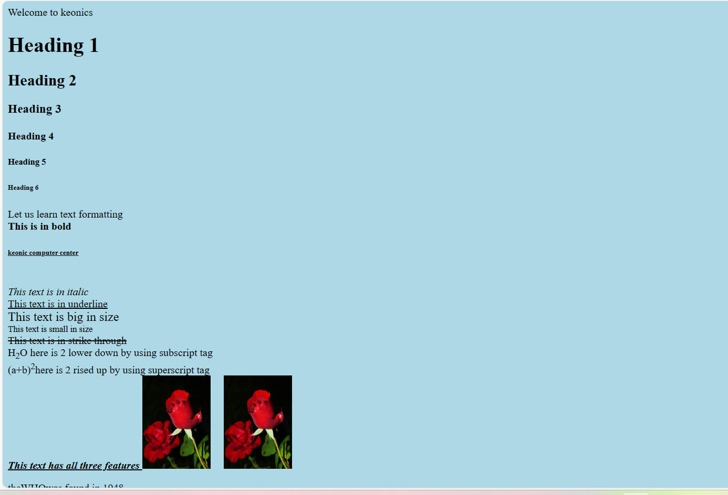<textarea rows="15" cols="25"> This is an example</textarea><html>

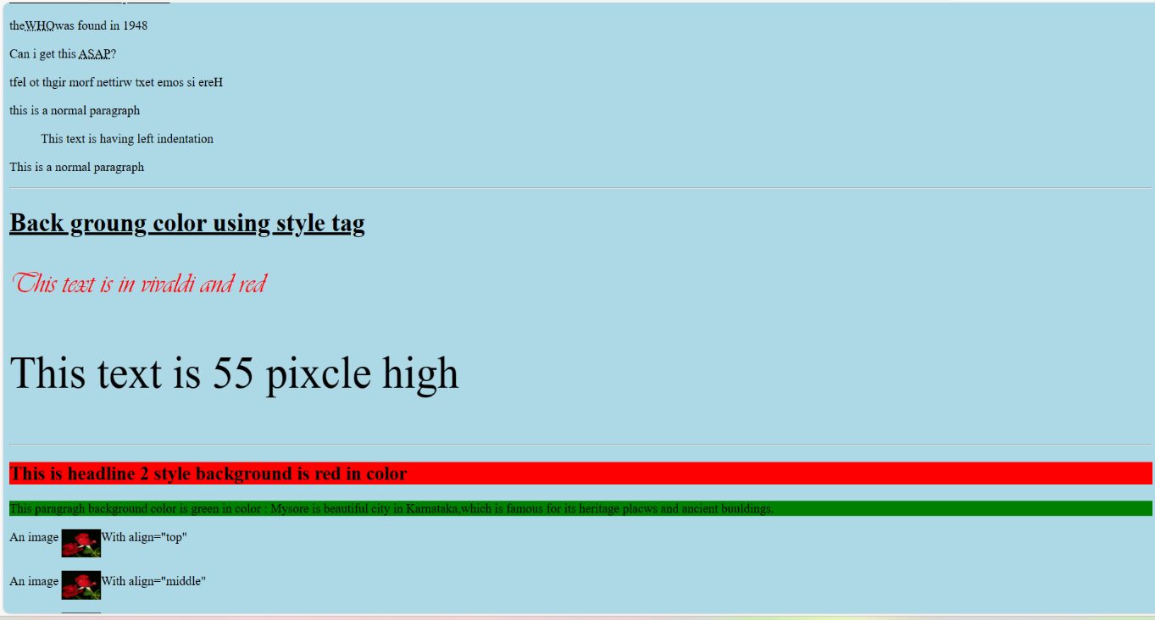

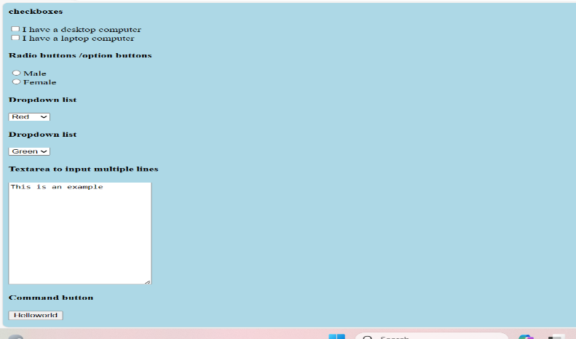

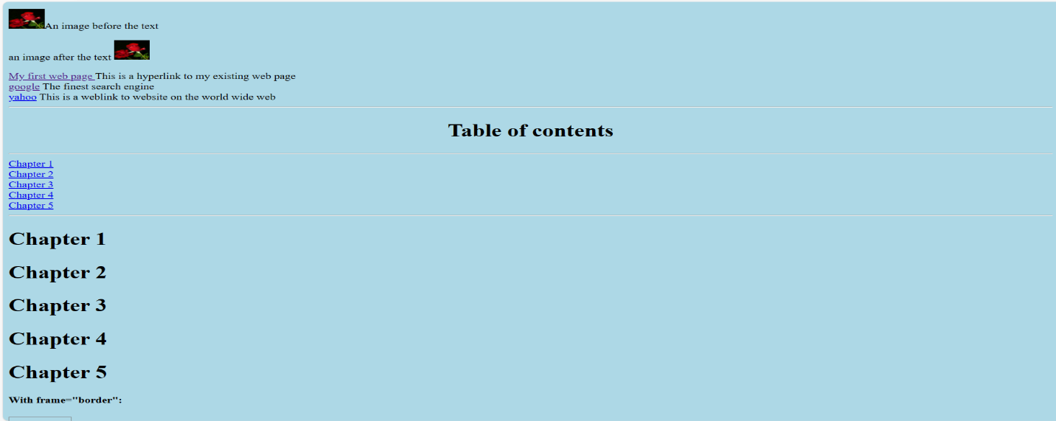

Web page using HTML

<html>

<head><title>web page</title></head>

<body style ="background-color:yellow">

<hr>

<h1 style="text-align:center;font-family:times;color:red">Welcome to Karnataka Tourism page </h1>

<hr>

<a href="pgm5.html">Home</a>&nbsp;&nbsp;

<a href="pgm6.html">About us</a>&nbsp;&nbsp;

<a href="pgm7.html">Gallery</a>&nbsp;&nbsp;

<a href="pgm8.html">Services</a>&nbsp;&nbsp;

<hr>

<p style="text-align:left;font-family:calibri;font-color:black"><br>

Karnataka is one of the largest state in India.Karnataka is known for its heritage places and natural parks/wildlife.It is also famous for beautiful hillstations,waterfalls ,beaches etc.Karnataka has different kinds of cuisines ,cultures,festivals,clothing etc.</p>

<p>Food culture of karnataka from spicy curies of the coastal region to the lentil dishes of the north to the sweetness of south

When it comess to clothing most of them prefer cotton dresses.There aremany types of materials in Karanataka.In karnataka mysore silk is most famous etc.

<img src="rosepic.jpg" align="right" width="200" height="200">

&nbsp;&nbsp;&nbsp;&nbsp;&nbsp;&nbsp;&nbsp;&nbsp;&nbsp;&nbsp;&nbsp;&nbsp;&nbsp;&nbsp;&nbsp;&nbsp;&nbsp;&nbsp;&nbsp;&nbsp;&nbsp;&nbsp;

&nbsp;&nbsp;&nbsp;&nbsp;&nbsp;&nbsp;&nbsp;&nbsp;&nbsp;&nbsp;&nbsp;&nbsp;&nbsp;&nbsp;&nbsp;&nbsp;&nbsp;

&nbsp;&nbsp;&nbsp;&nbsp;&nbsp;&nbsp;&nbsp;&nbsp;&nbsp;&nbsp;&nbsp;&nbsp;&nbsp;&nbsp;

&nbsp;&nbsp;&nbsp;&nbsp;&nbsp;&nbsp;&nbsp;

<hr>

<formaction="">

<h4>Top tourist pllaces in Karnataka</h4>

<textarea rows="15" cols="25">

Mysore palace,Mysore

Chamundi hills ,Mysore

Jog falls,Shivmogga

Mullayangiri,Chikmagaluru

Raja Seat,Madikeri

Om beach,Mangalore

KRS dam,Mandya

</textarea>

<h4>Select the area of Karnataka </h4>

<input type="radio" name="area" value="East">East<br>

<input type="radio" name="area" value="West">West<br>

<input type="radio" name="area" value="North">North<br>

<input type="radio" name="area" value="South">South<br>

<h4 style="font-family:vivaldi;color:darkblue">Select the District to visit</h4>

<select name="District">

<option value="Banglore">Bangalore</option>

<option value="mysore">Mysore</option>

<option value="Mandya">Mandya</option>

<option value="Chamrajnagar">Chamrajnagar</option>

<option value="kengeri">kengeri</option>

</select><br>

Name: <input type="text" name="Name"><br>

Age: <input type="text" name="Age"><br>

Password: <input type="password" name="password"><br>

<h4 style ="text-align:center;font-family:aries;font-color:violet">

THANK YOU FOR VISTING THIS PAGE

</h4>

</form>

</body></html>

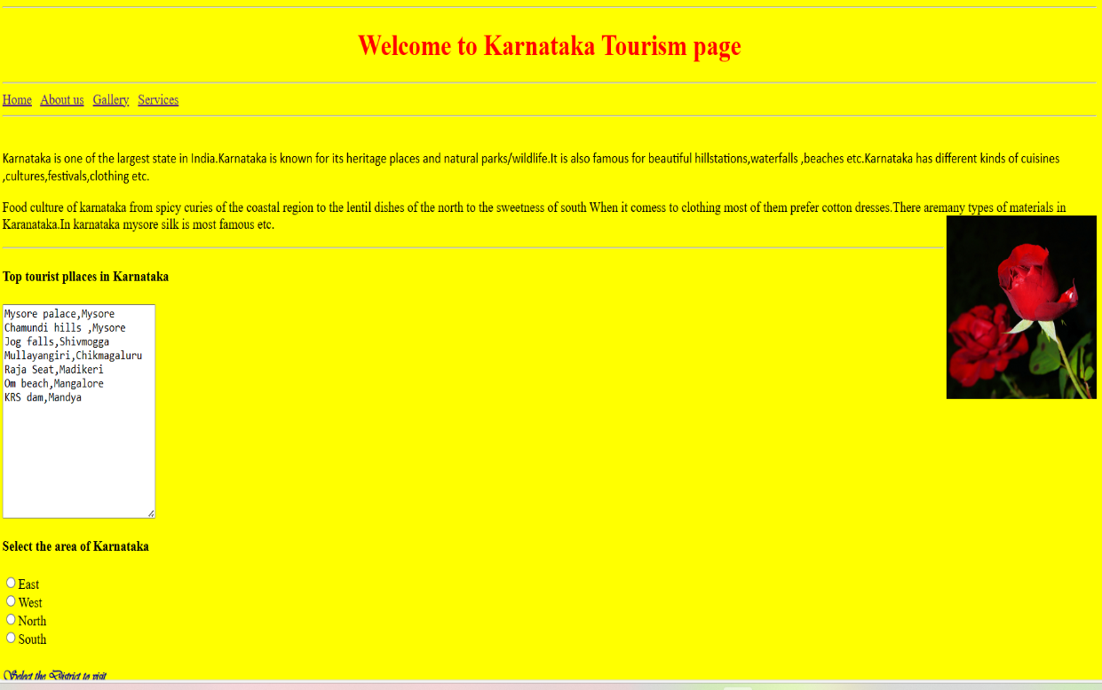

DHTML/CSS

DHTML: Dynamic Hyper Text Markup Language

CSS: Cascading Style Sheet

* If HTML is the structure of house then CSS is the look and feel of the house.
* It’s the language to make our webpages presentable .
* Design to make stylesheets for web.
* CSS can control the layouts of multiple web pages all at once.

Web Page using HTML and CSS

<!DOCTYPE html><head>

<title>Sample web page </title>

<link rel="stylesheet" type="text/css" href="style.css">

</head>

<body>

<div id="topbar">

</div>

<div id="container">

<div id="header">

<img src="image/logo.png">

<ul>

<li><a href="#">Home</a></li>

<li><a href="#">About us</a></li>

<li><a href="#">Service</a></li>

<li><a href="#">Gallery</a></li>

<li><a href="#">Portfolio</a></li>

<li><a href="#">Contact Us</a></li>

</ul>

</div>

<div id="banner">

<img src="image/lekha prakashana.jpg">

</div>

<div id="content1">

<h4 class="heading">WELCOME!!</h4>

<p class="para1"> Lekha prakashana is a small book publication company handled by Mrs.Banumathi N V .It is a small start up which has completed almost 7 years in this field. The main motto of this publication is to provide some good and knowledgable books to the readers.</p>

<a href="#" class="more">Read more..</a></div>

<div id="content2">

<h4 class="heading">Our Services</h4>

<p class="para1">Mainly we publish various story books it may be small storybook or a book about the ancient culture or the rulers .

Not only publishing even we facility of all the requirements of piblushing a book from the scratch .For example typing the script,layout of script,printing we have all the contacts to fulfill ones requirement.

</p>

<a href="#" class="more">Read more..</a>

</div>

<div id="content3">

<h4 class="heading">About Us!</h4>

<p class="para1">Our proprietor is Mrs.Banumathi NV she has more than 20 years of experience in DTP.So has some knowledge about book publication"

</p>

<a href="#" class="more">Read more..</a></div>

<div id="bottom1">

<h2>About the publication</h2>

<p> A publication is something made to communicate with the public. Publications are usually printed on paper (like magazines and books), but online publications are delivered via the Internet. </p><br>

<h2>Government affiliated progrms regarding publication</h2>

<p> A government publication is defined in the U.S. Code (44 U.S.C. 1901) as "... informational matter which is published as an individual document at Government expense, or as required by law."

Publication Categories

ART AND CULTURE.

<ul>c

<li>BUILDERS OF MODERN INDIA (BMI SERIES)</li>

<li>CHILDREN'S LITERATURE.</li>

<li>COLLECTED WORKS OF MAHATMA GANDHI.</li>

<li>CULTURAL LEADERS OF INDIA (CLI SERIES)</li>

<li>FLORA&FAUNA</li>.

<li>GANDHIAN LITERATURE.</li>

<li>HEALTH AND NUTRITION.</li>

</ul> </p><br>

<a href="#">Read more....</a>

</div>

<div id="bottom2">

<h2>Sample book</h2>

<img src="image/banner2.png" width="80%" height="340px"/>

</div>

</div>

<div id="footer">

<p>&copy;2023|Designed by Anisha Thandavamurthy</p></div>

</body></html>

CSS CODE

#topbar

{ background-color:#1f1f1f; height:20px;width:100%;}

body{ background-color:#ffefd5;}

#container

{ width:100%;margin:0px auto;}

#header

{ height:80px; background-color:#fefefe;}

header img

{height:20px;}

#header ul

{float:right;margin-top:25px;}

#header ul li

{ display:inline;margin-right:25px;}

#header ul li a

{ color:gray; text-decoration:none;font-size:18px;}

#banner img

{width:100%;padding-bottom:20px;}

#content1

{width:33%; height:350px;background-color:#f86900;float:left; margin-right:2%;}

#content2

{width:32%; height:350px;background-color:#ffc502; float:left;}

#content3

{width:32%; height:350px;background-color:#a2c511; float:right;}8

.heading

{ color:white; margin-left:20px;font-size:28px;}

.para1

{ color:white;margin-left:20px;margin-right:80px;}

.more

{text-decoration:none;color:black;background-color:white; padding:8px;margin-left:20px;}

#bottom1

{ margin-top:15px;width:60%;float:left;}

#bottom2

{margin-top:15px;width:40%; float:right;}

#bottom1 h2

{color:black;margin-left:20px;}

#bottom1 p

{margin-left:20px;color:black; margin-right:8px;}

bottom1 a

{ margin-left:20px; color:orange;}

#bottom2 h2

{ color:black; margin-left:20px;}

#footer

{ width:100%; height:60px; background-color:black; clear:both;}

#footer p

{ color:white; float:right; margin-right:20px;}

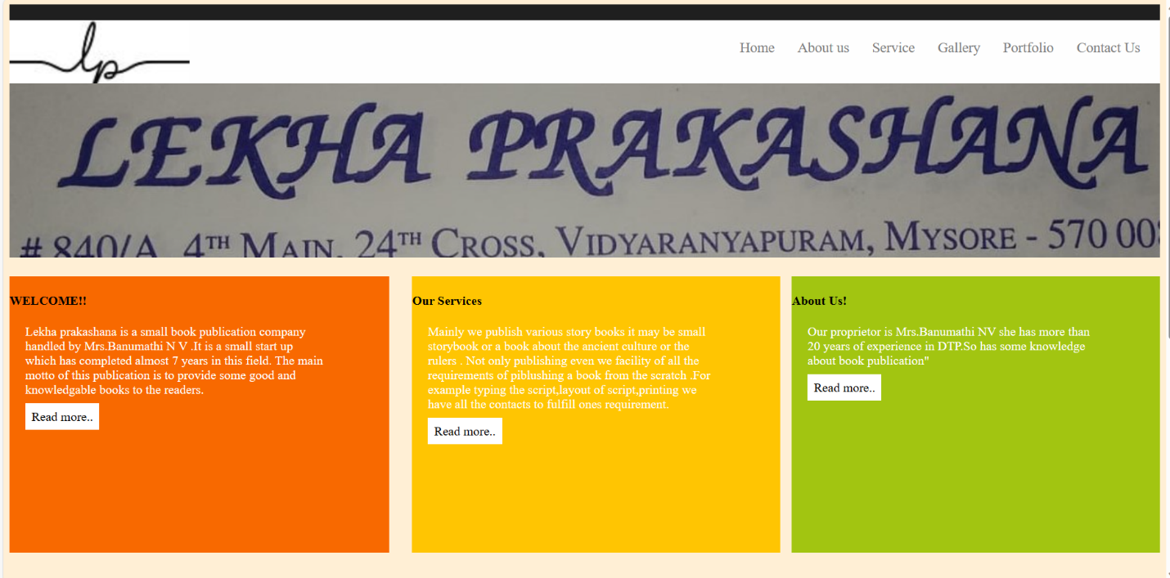

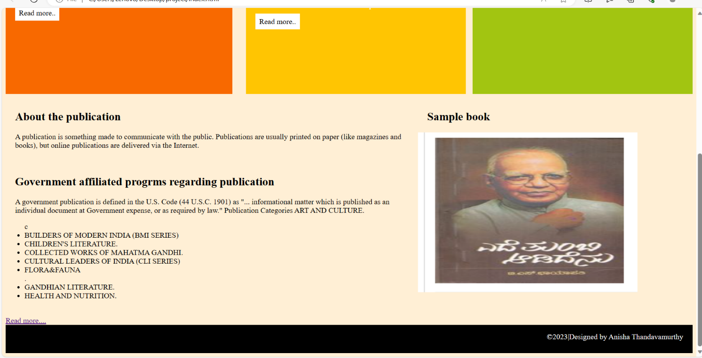

Java Script

Java Script is a light weight programming language commonly used by web developers to add dynamic interactions to webpages , applications , servers , and even games.

It works seamlessly alongside HTML and CSS , complementing CSS in formatting HTML elements while providing user interaction , a capability that CSS alone lacks .

Conditional Control Statements

1. If statement (one way branch)
2. If else statement(two way branch)
3. If else if else statement(ladder if)
4. Nested if statement
5. Switch statement

Loop Control Statements

1. For Loop
2. While Loop
3. Do While Loop
4. Nested For Loop